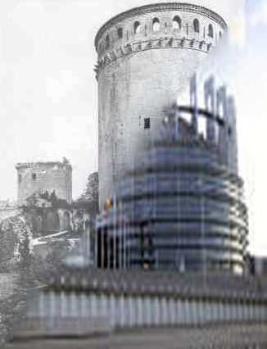
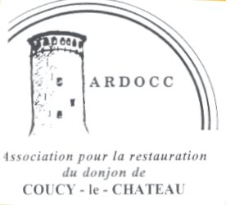

M Louis Trémolières on the 20 octobre 2018
29 rue du Bois l’Abbé
La butte du Roy
02700 Frières-Faillouël
Tel 03 23 52 58 34
Tel portable 06 70 29 06 26
Mail:louis.tremolieres@orange.fr

To European Party groups

Obj : Coucy-Le-Château, claim from l’ARDOCC , association pour la restauration du Donjon de Coucy, for a token of franco-german reconciliation and as an european symbol

Dear Sirs ,

By means of a petition registered in 2004, A.R.D.O.C.C: Association pour la restauration du donjon de Coucy -Le-Château, has called for an examination by the European Parliament of its proposal, i.e. the rebuilding of the Donjon of Coucy as a monument symbolising peace and european unity.

On the eve of 2019 and the new general consultation, the european project seems more fragile than ever. Ardocc is not a lot astonished by this situation, because it is convinced that nothing will be erected firmly on a message of hate, which is incorporated in the perdurance of ruins lying so « in order to show to the future generations the german people's barbarism», which is unacceptable because nobody has been really questioned before.

There is no other way to weight the responsability of all goverments since 1917, than by counting deads in the WW1 and WW2, by considering the results of the cold war and by stating the pattern given to all terrorist movements to destroy antique monuments of civilizational value .

Recently, ONU and UNESCO decreeted the duty to rebuild all monuments sacrified by retaliation or people's humiliation during wars or unrest times.

Coucy bears all the stigmates of bad decisions taken by the most important european countries’ leaders in the last hundred years .

At the end of 1916, France has refused the Austrian emperor's peace process ; the preussian Kaiser hasn't stop the german rabble of soldiers, Hindenburg and Luddendorf, who soon after knighted Hitler ; after the war only bad diplomatical and financial decisions have been taken ….. all these issues are visible in the disrepair or ruined state of Coucy-Le-Château, which was once all around the world called Coucy-La-Merveille.

The next european general election makes compulsory to the candidate movements the display of clear programs and positions in order to allow the voters a choice and to give the deputees a fair mandate.

During this challenging times, it matters, that the members and friends of our Association may know the point of view of your political movement on the following points.
We would be grateful for an answer before the :
15th of february 2019

a) Europe has symbols ; a flag, an hymn, of german origin , a language, english . Do you think that a symbol brought by France and Germany as peace symbol between the two countries and realized by means of european fonds and finances could be a really entrusting symbol of the european construction .
YES NOT
b) after having taken notice of the history and the architectural value of Coucy-Le-Château, do you think, that pursuing the state of ruins is an injury to the european civilization ?
YES NOT
c) Do you agree that the french State, for internal reasons, may keep on a message of hate on european ground .
YES NOT
  - Do you consider right and accurate the wish of Otto de Habsbourg, who has been a european Parlement's pillar, and a ARDOCC supporter, to rebuild the donjon ?

YES NOT

We do express in advance our thanks for your answers and considerations, being sure that yours actions will bring a better future for the forthcoming generations. The aim of ARDOCC is only peace and confidence in our common foundations.

Pour l'ARDOCC
Louis Trémolières

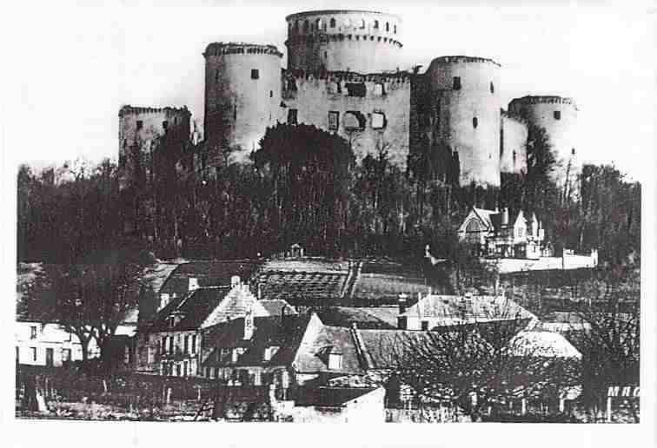 See : http:// www.donjondecoucy.com
